## PROJECT 2 PROPOSAL

**Topic:** Air Quality & Pollution Over Time

**Dataset(s)**

1. <https://www.iqair.com/air-pollution-data-api>

**Visualization Inspiration:**

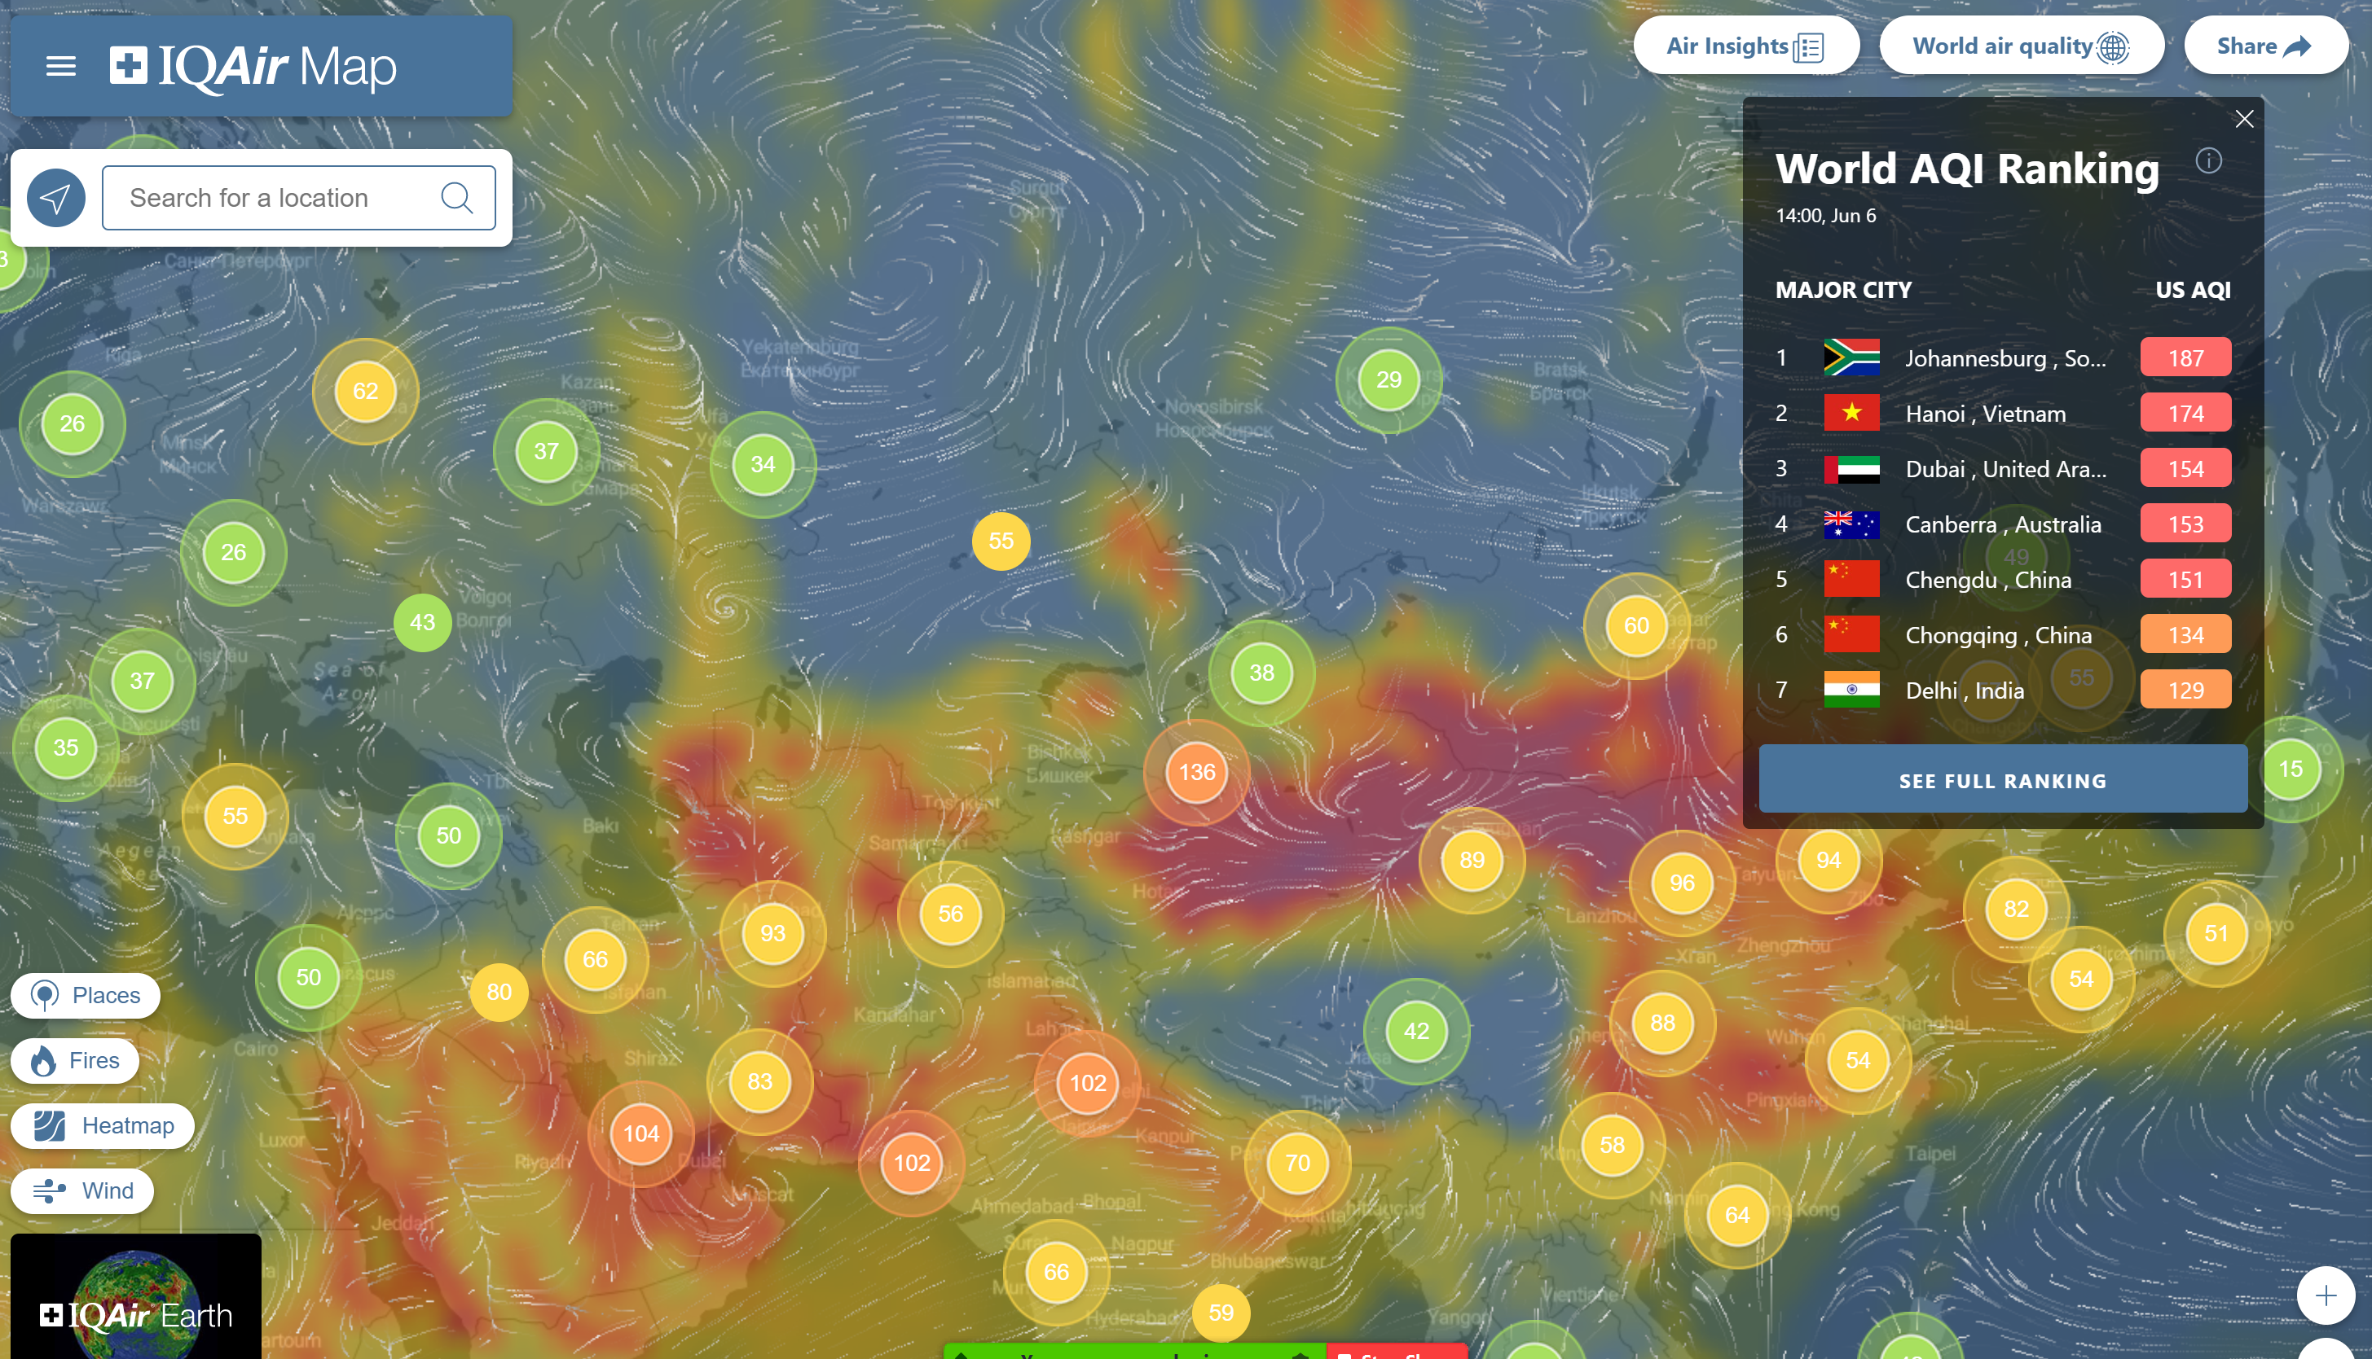

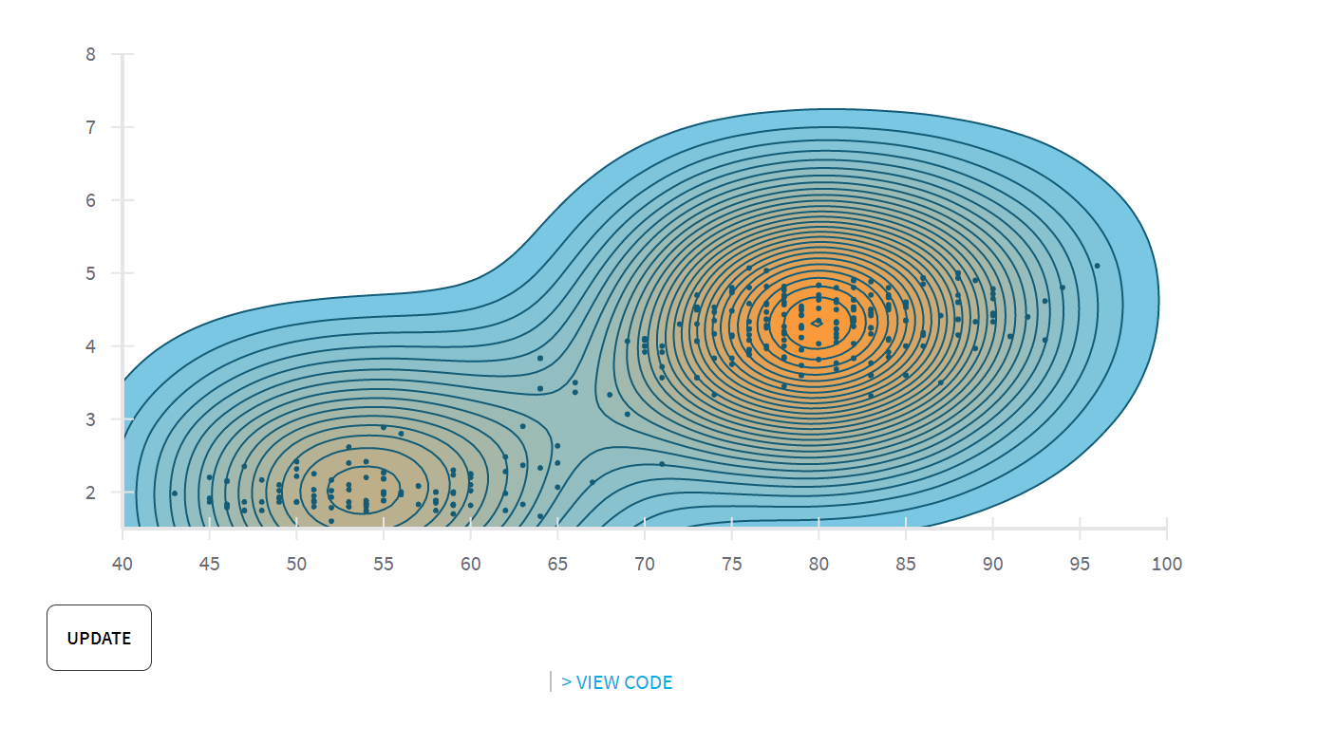

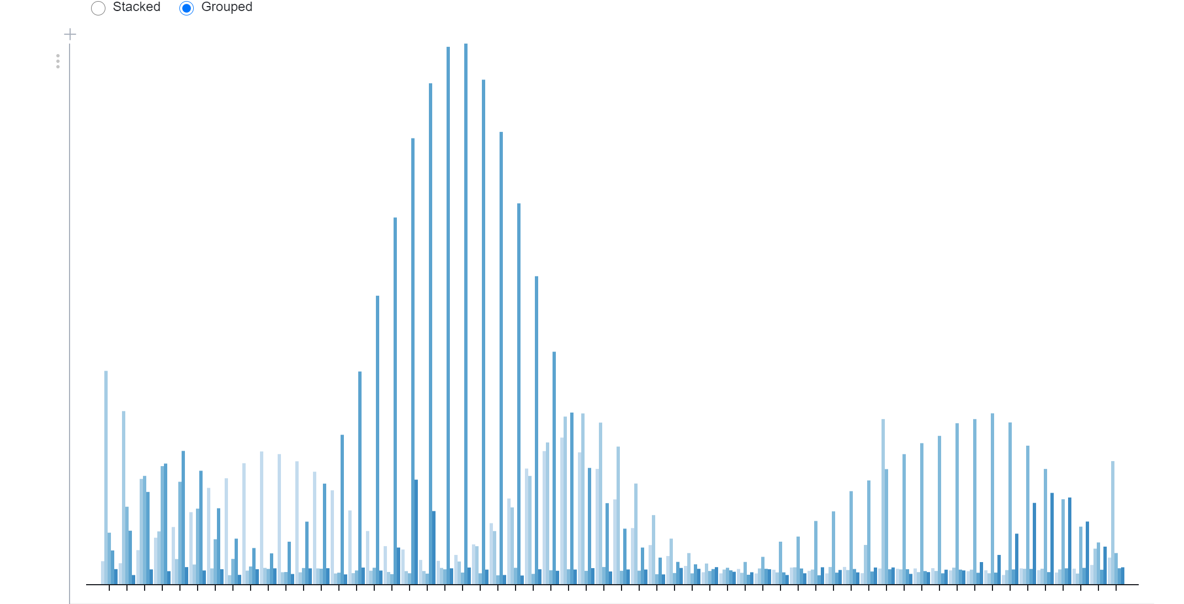

* Stations around the world have update cycles that are all different from each other.
* Stations are updated only once per hour.
* The API returns calculated AQI for each pollutant and for the station (main pollutant).
* The API returns 2 types of AQI: US AQI (EPA) and Chinese AQI.

"forecasts": [ //object containing forecast information

{

"ts": "2017-02-01T03:00:00.000Z", //timestamp

"aqius": 21, //AQI value based on US EPA standard

"aqicn": 7, //AQI value based on China MEP standard

"tp": 8, //temperature in Celsius

"tp_min": 6, //minimum temperature in Celsius

"pr": 976, //atmospheric pressure in hPa

"hu": 100, //humidity %

"ws": 3, //wind speed (m/s)

"wd": 313, //wind direction, as an angle of 360° (N=0, E=90, S=180, W=270)

"ic": "10n" //weather icon code, see below for icon index

},

… // contains more forecast data for upcoming 76 hours

]

"pollution": {

"ts": "2017-02-01T01:15:00.000Z",

"aqius": 18,

"mainus": "p1", //main pollutant for US AQI

"aqicn": 20,

"maincn": "p1", //main pollutant for Chinese AQI

"p1": { //pollutant details, concentration and appropriate AQIs

"conc": 20,

"aqius": 18,

"aqicn": 20

}

}